On-Chain Settlement
# Source: AI Source: Provided by: [Data Path: Persons Table -> ID Column: 1, Name_En Column: Motasem Essam] -> From: [ChatGPT] on [1/21/2026]
On-chain settlement refers to the process where cryptocurrency transactions are executed and recorded directly on a blockchain, such as Bitcoin, Ethereum, or Solana. The settlement is final and publicly verifiable, meaning that once confirmed, the transaction cannot be reversed.

🧠 Simple Definition
# Source: AI Source: Provided by: [Data Path: Persons Table -> ID Column: 1, Name_En Column: Motasem Essam] -> From: [ChatGPT] on [1/21/2026]
On-chain settlement means the transfer of crypto assets is processed and finalized directly on the blockchain network — where the transaction is transparent, timestamped, and irreversible.

🔗 How It Works
# Source: AI Source: Provided by: [Data Path: Persons Table -> ID Column: 1, Name_En Column: Motasem Essam] -> From: [ChatGPT] on [1/21/2026]
- A sender creates a transaction (e.g., sending BTC to another wallet).
- The transaction is broadcast to the blockchain network (e.g., Bitcoin nodes).
- Validators or miners verify and include it in a new block.
- After network confirmation (1+ blocks), the transaction is considered settled.
- Funds appear in the recipient’s wallet, with a permanent record on-chain.

💡 Examples of On-Chain Settlement Networks
# Source: AI Source: Provided by: [Data Path: Persons Table -> ID Column: 1, Name_En Column: Motasem Essam] -> From: [ChatGPT] on [1/21/2026]
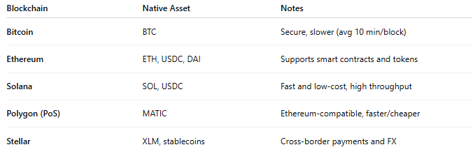

Blockchain | Native Asset | Notes
Bitcoin | BTC | Secure, slower (avg 10 min/block)
Ethereum | ETH, USDC, DAI | Supports smart contracts and tokens
Solana | SOL, USDC | Fast and low-cost, high throughput
Polygon (PoS) | MATIC | Ethereum-compatible, faster/cheaper
Stellar | XLM, stablecoins | Cross-border payments and FX

🔍 Characteristics of On-Chain Settlement
# Source: AI Source: Provided by: [Data Path: Persons Table -> ID Column: 1, Name_En Column: Motasem Essam] -> From: [ChatGPT] on [1/21/2026]
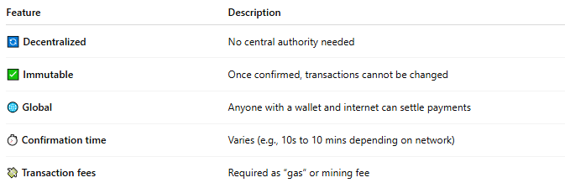

Feature | Description
🔄 Decentralized | No central authority needed
✅ Immutable | Once confirmed, transactions cannot be changed
🌐 Global | Anyone with a wallet and internet can settle payments
⏱️ Confirmation time | Varies (e.g., 10s to 10 mins depending on network)
💸 Transaction fees | Required as “gas” or mining fee

✅ Use Cases
# Source: AI Source: Provided by: [Data Path: Persons Table -> ID Column: 1, Name_En Column: Motasem Essam] -> From: [ChatGPT] on [1/21/2026]
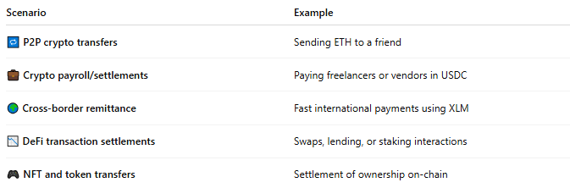

Scenario | Example
🔁 P2P crypto transfers | Sending ETH to a friend
💼 Crypto payroll/settlements | Paying freelancers or vendors in USDC
🌍 Cross-border remittance | Fast international payments using XLM
📉 DeFi transaction settlements | Swaps, lending, or staking interactions
🎮 NFT and token transfers | Settlement of ownership on-chain

🔐 Security & Finality
# Source: AI Source: Provided by: [Data Path: Persons Table -> ID Column: 1, Name_En Column: Motasem Essam] -> From: [ChatGPT] on [1/21/2026]
- Cryptographically secure
- Final after confirmation (e.g., 6 blocks in Bitcoin, ~12 in Ethereum)
- No central bank or reversal possible
- Full audit trail on public ledger

🧾 Example: Ethereum On-Chain Settlement Flow
# Source: AI Source: Provided by: [Data Path: Persons Table -> ID Column: 1, Name_En Column: Motasem Essam] -> From: [ChatGPT] on [1/21/2026]
- User signs transaction to send 1 ETH to another wallet.
- Transaction is sent to Ethereum network and enters the mempool.
- Miner/validator includes it in the next block.
- After 12 confirmations → the transaction is final.
- Both parties can see the transaction on Etherscan.

⚖️ Pros & Cons of On-Chain Settlement
# Source: AI Source: Provided by: [Data Path: Persons Table -> ID Column: 1, Name_En Column: Motasem Essam] -> From: [ChatGPT] on [1/21/2026]
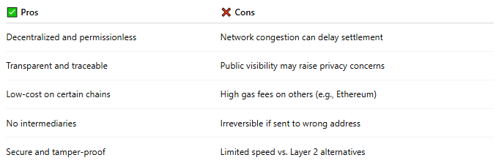

✅ Pros | ❌ Cons
Decentralized and permissionless | Network congestion can delay settlement
Transparent and traceable | Public visibility may raise privacy concerns
Low-cost on certain chains | High gas fees on others (e.g., Ethereum)
No intermediaries | Irreversible if sent to wrong address
Secure and tamper-proof | Limited speed vs. Layer 2 alternatives

🧠 Summary
# Source: AI Source: Provided by: [Data Path: Persons Table -> ID Column: 1, Name_En Column: Motasem Essam] -> From: [ChatGPT] on [1/21/2026]
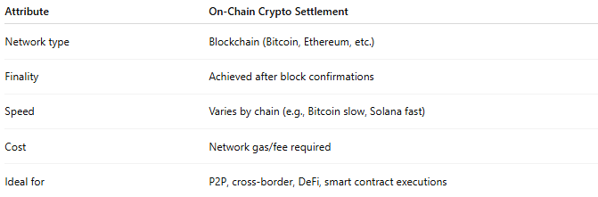

Attribute | On-Chain Crypto Settlement
Network type | Blockchain (Bitcoin, Ethereum, etc.)
Finality | Achieved after block confirmations
Speed | Varies by chain (e.g., Bitcoin slow, Solana fast)
Cost | Network gas/fee required
Ideal for | P2P, cross-border, DeFi, smart contract executions

